Carvings Available Now
- Eagles & other carvings on my website (www.LineAndBerry) that are not pictured here can be made to order with a typical lead time of 3-4 months. See the website for more info & photos of all of my pieces.
- I can also work with you to carve any ideas you may have.
- Eagles are gilded with 24 karat gold unless otherwise stated.
- Price list on request. Questions or enquiries ----> Email me at dei.gratia123@gmail.com
- Follow me on Instagram: William Francis Brown (@williamfrancisbrown) •
New carvings approx. every 3-4 months
- William Francis Brown (@williamfrancisbrown) • Instagram photos and videos
Wm. Francis Brown Forest, VA
434-907-5427 dei.gratia123@gmail.com

- 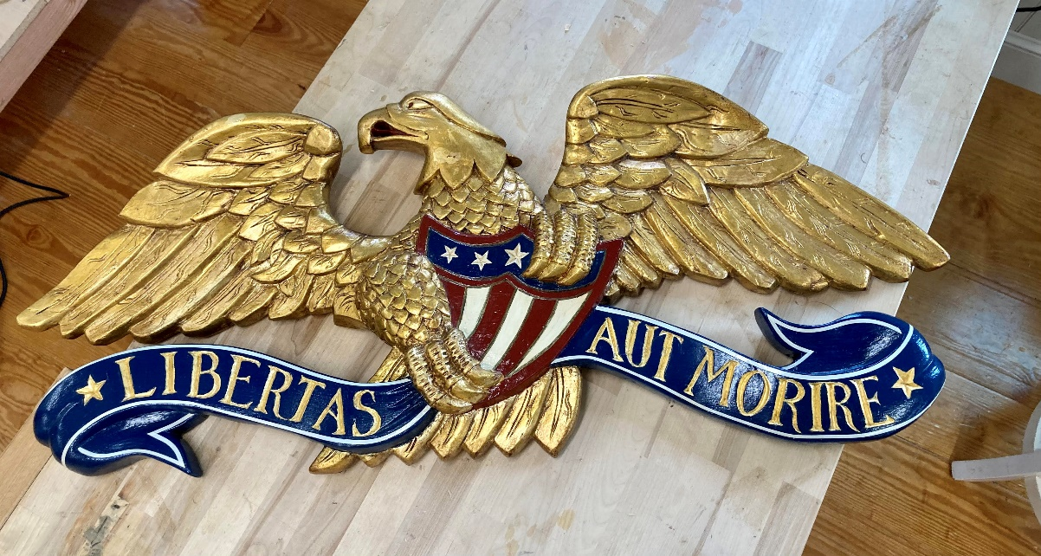
1812 Eagle 35” span x 15” tall x 3” deep Mildly antiqued gold leaf. $5000 SOLD 10/9/23
An eagle of this design with Banner reading “E. Pluribus Unum” is immediately available.
- 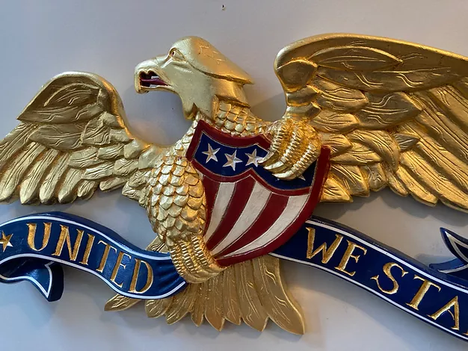
1812 Eagle 35” span x 16 x 3” $5000 SOLD
- 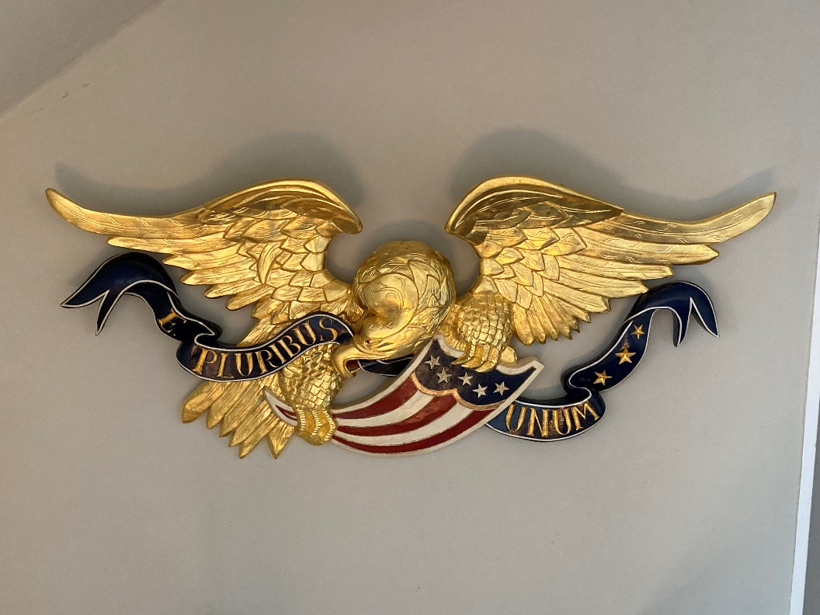
Boston Eagle 47” span x 21” tall x 5 ½” deep - SOLD $17,000

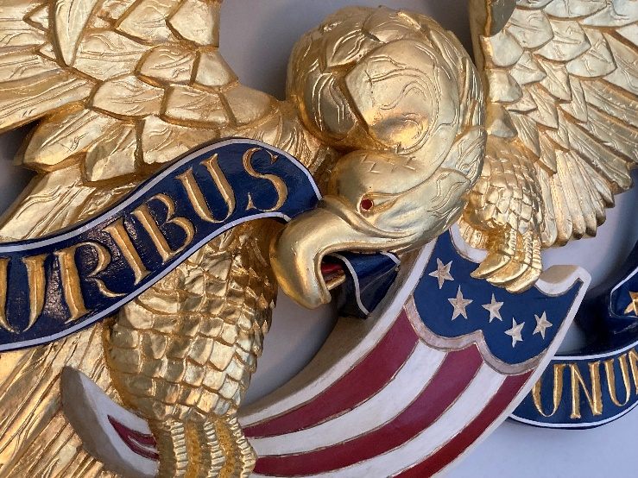
Detail of #3

- 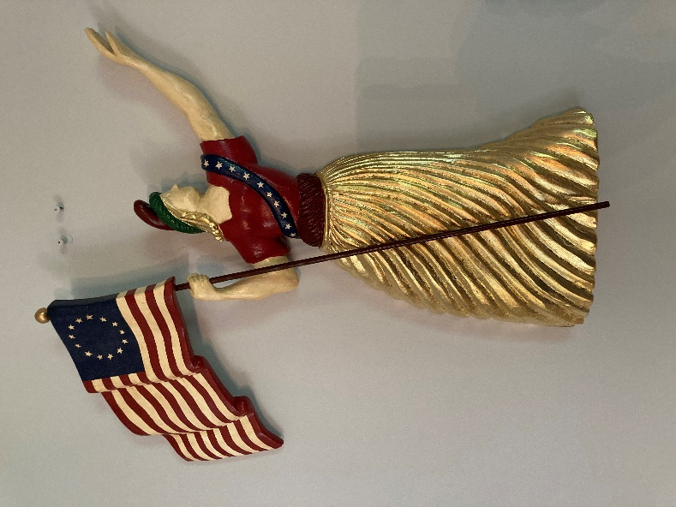

Lady Liberty 18 ½”x 19” x 2 ½” $3,100

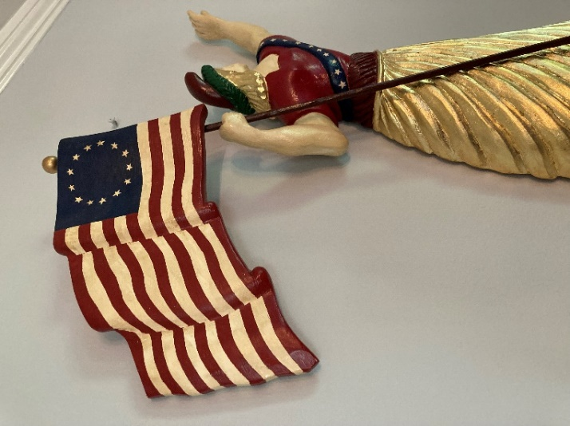

- 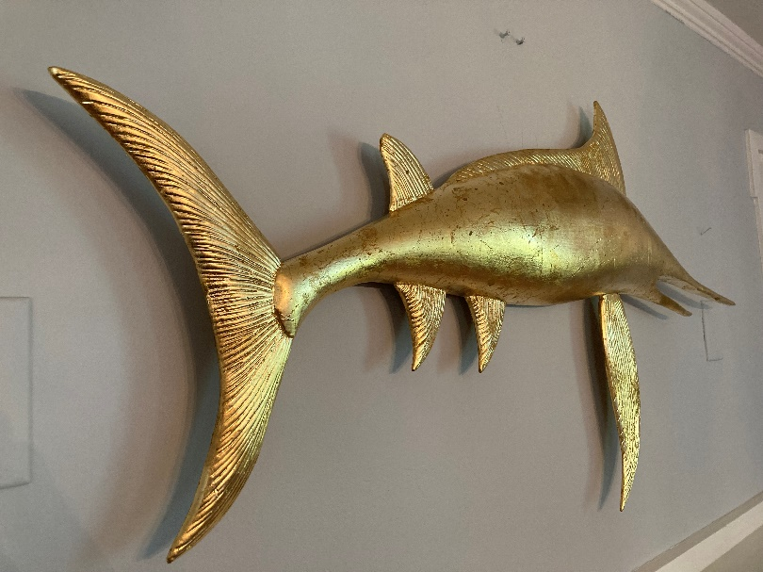

Swordfish 45” wide x 23” tall x 3 “ deep. Moderately antiqued & distressed gold leaf.
$3,200

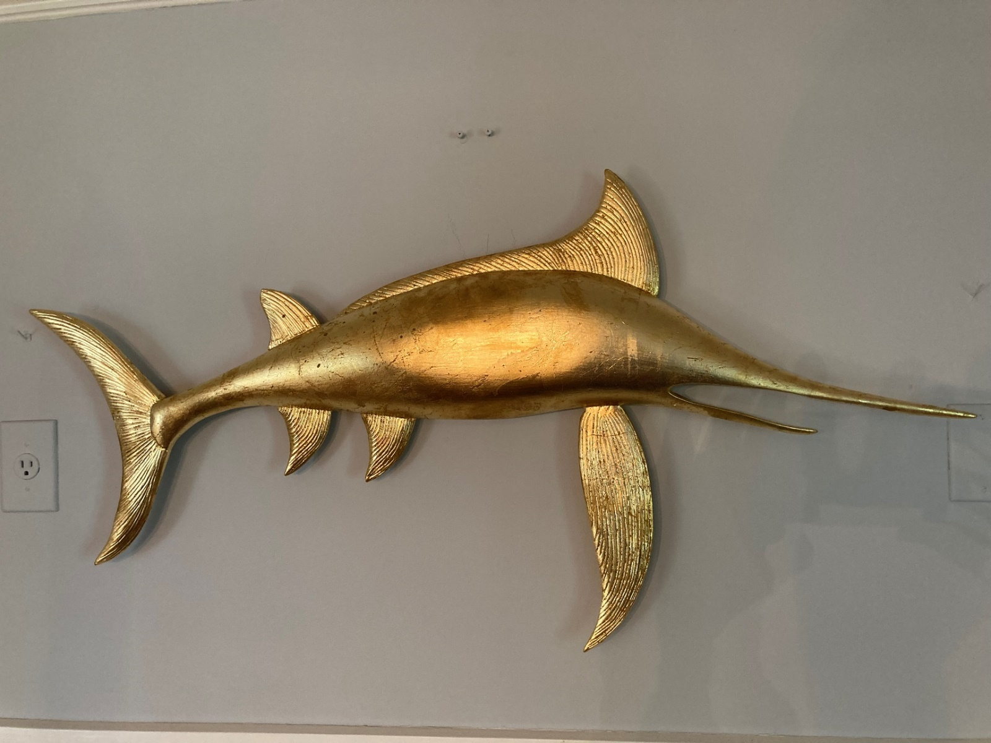

- .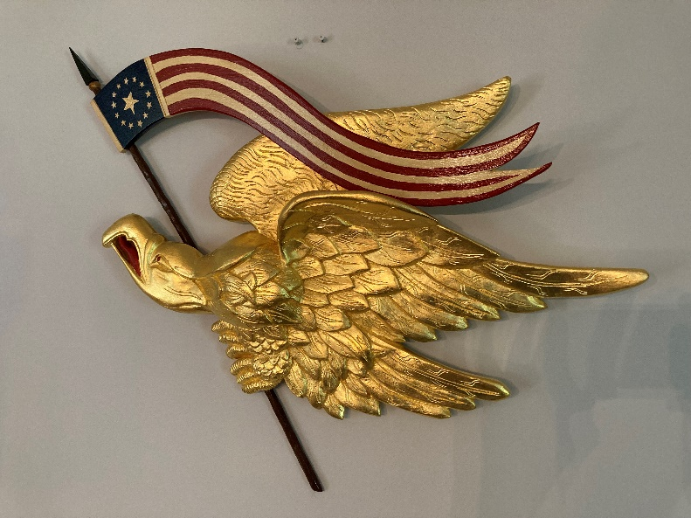
Liberty Eagle 33” wide x 24” tall x 4” deep See more banner options below or on my website. $5,500

- Americana Eagle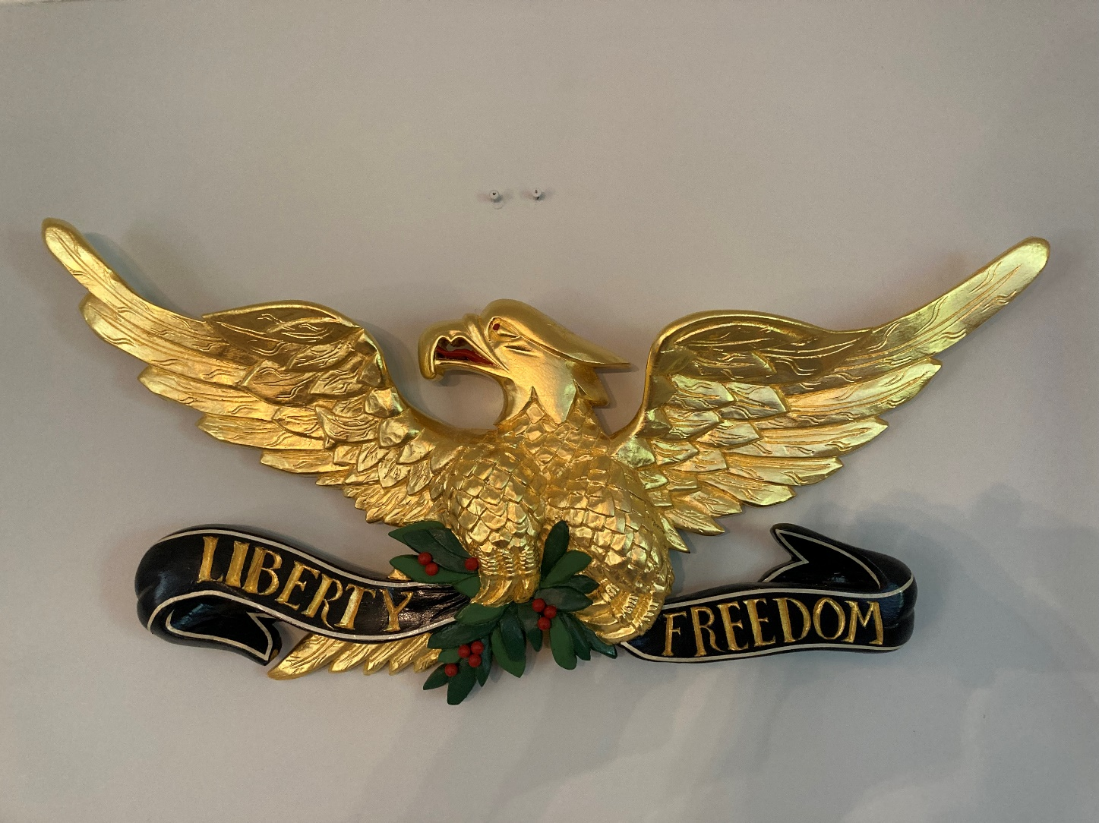
31” span x 16” tall x 3” deep $4,200

. 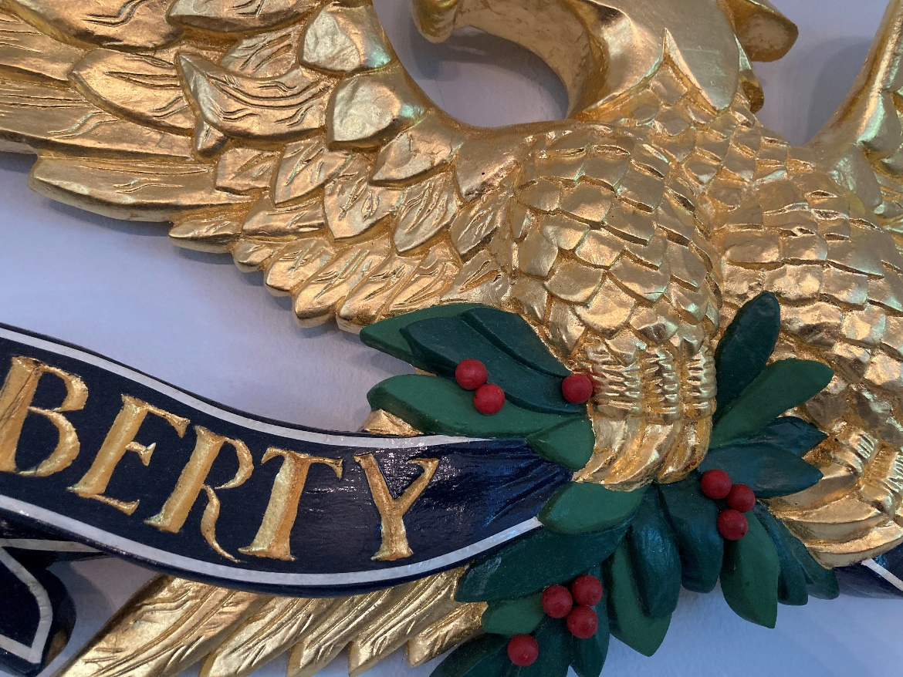 Detail of #7

8. Resolute Eagle
8. 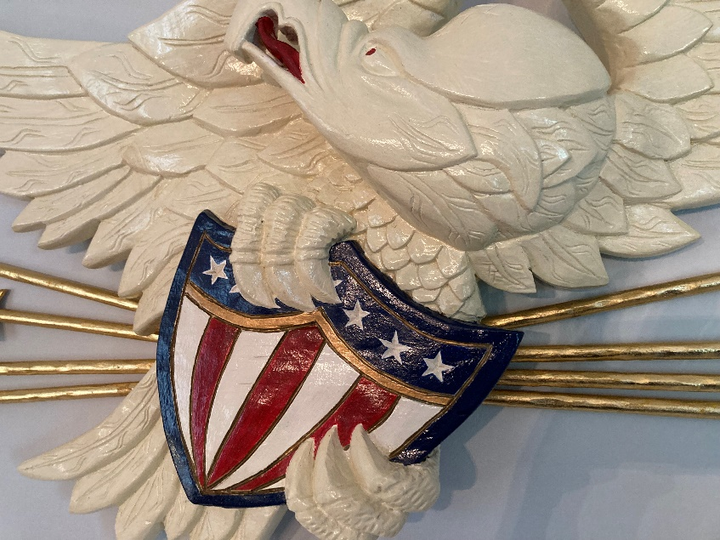 48” wide x 20” tall x 5” deep
$5,100 Original design.

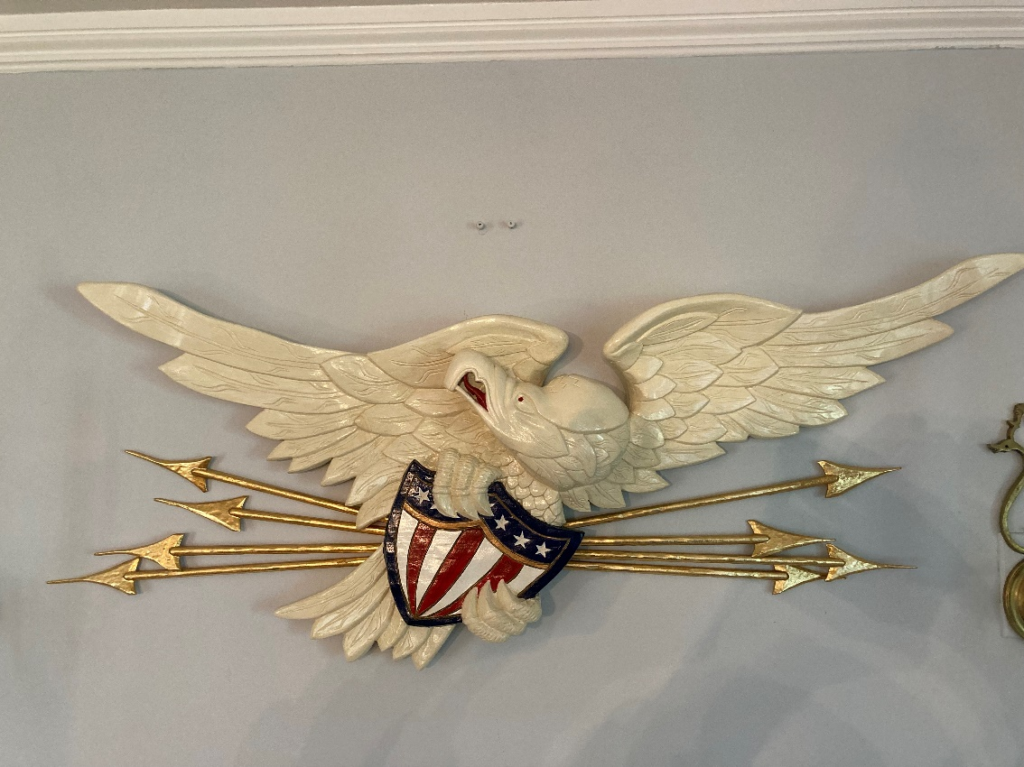

8. 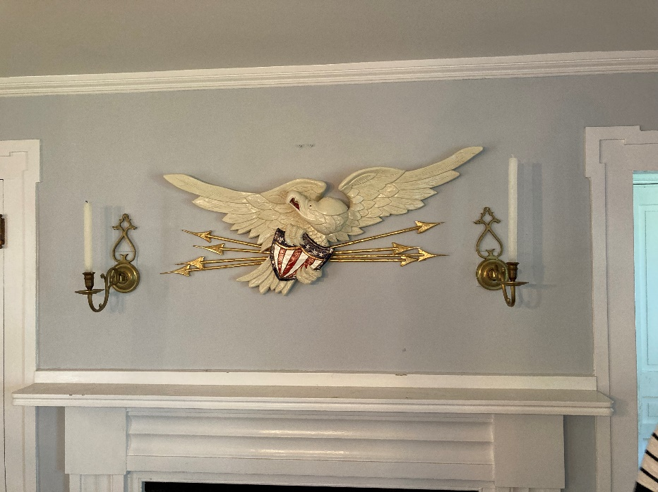

Available with or without arrows, Arrows can also be brown or green.

9. 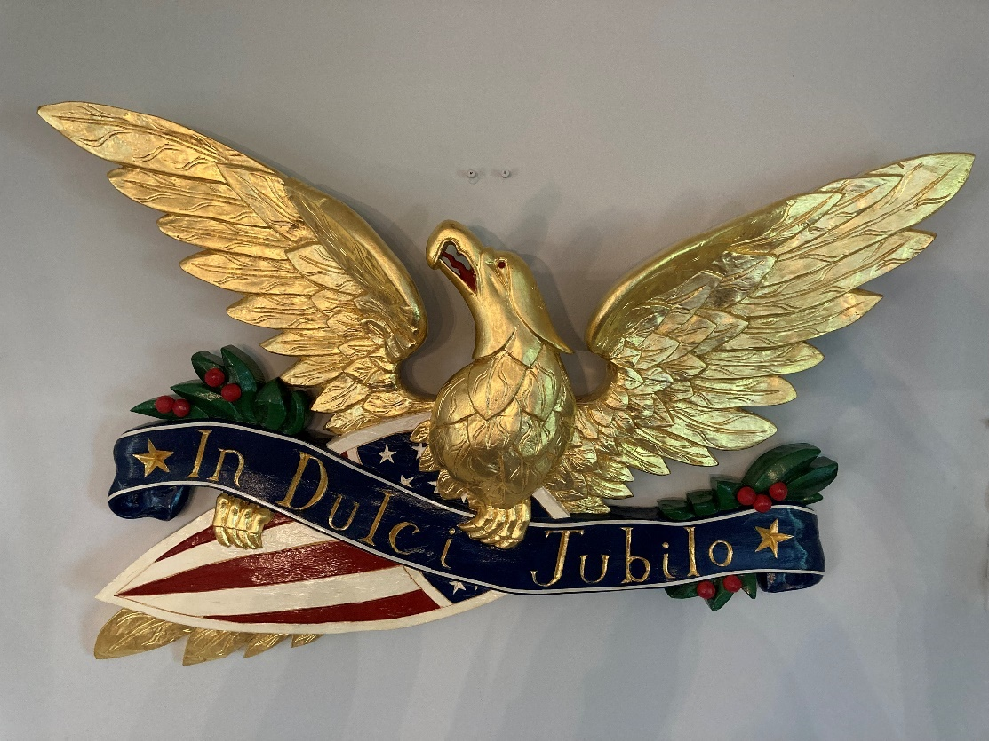

“In Dulci Jubilo” (With Sweet Rejoicing) Original design; 38” span x 23” tall x 4” deep

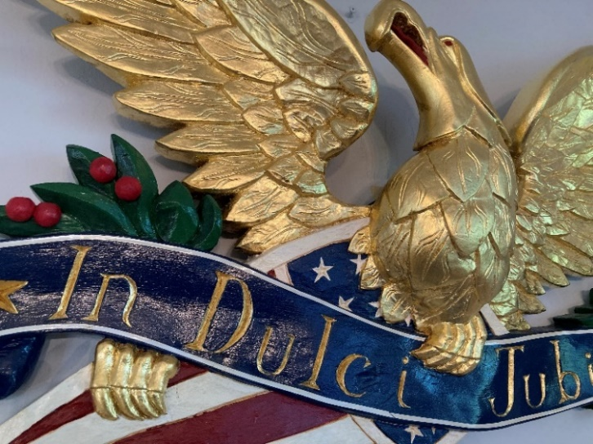
10. 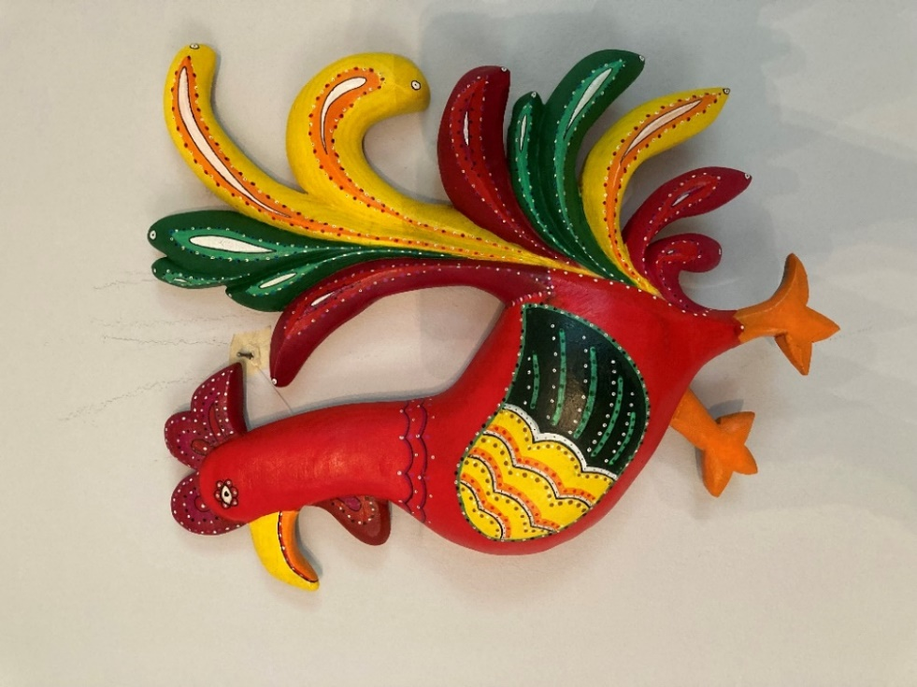
Fancy Rooster I (original design) 16” tall x 12” wide x 2 ½” deep
SOLD $950

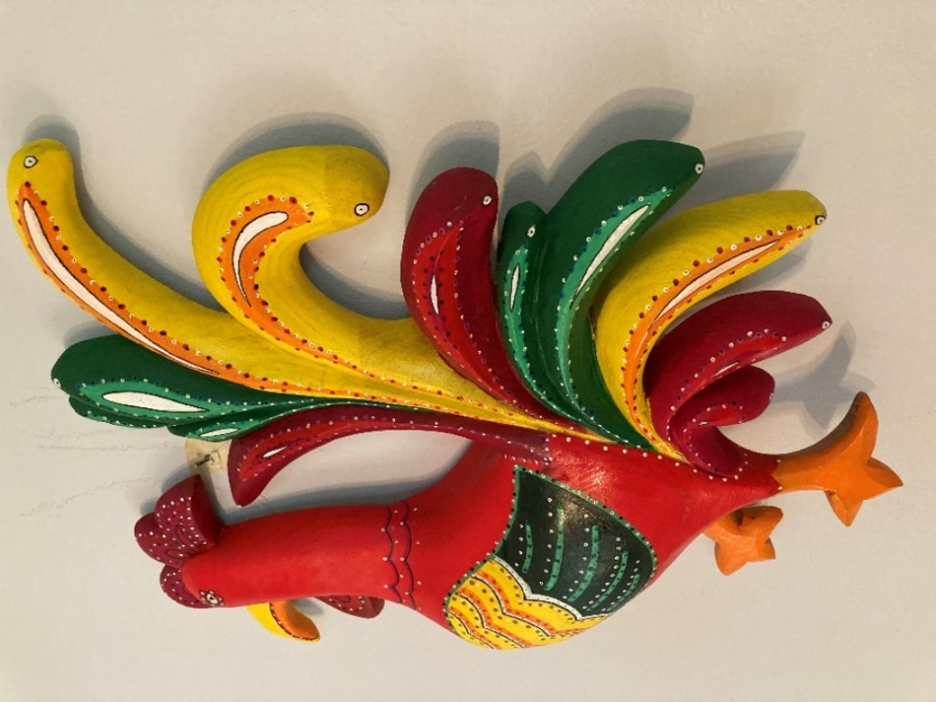
11. 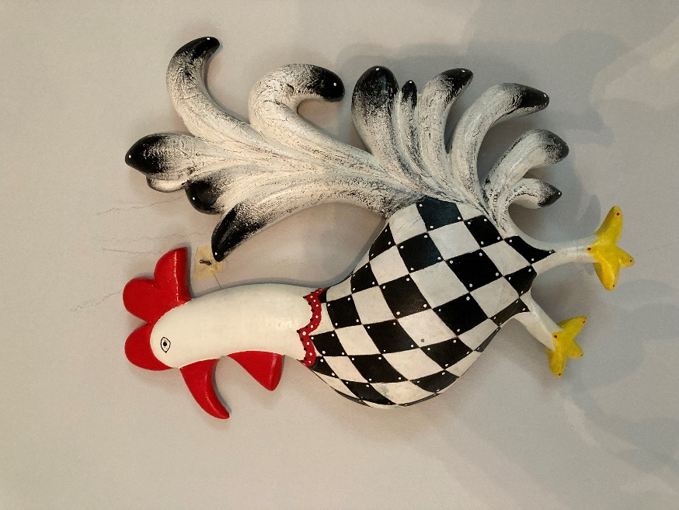

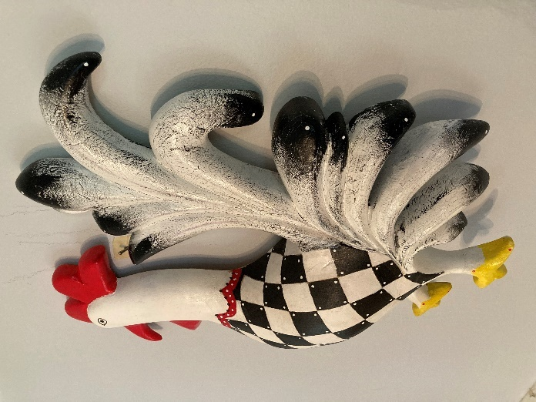

Fancy Rooster II 16” tall x 12” wide x 2 ½ ” deep SOLD $950
________________________________________________________________________________________

12. Reverse Wing Bellamy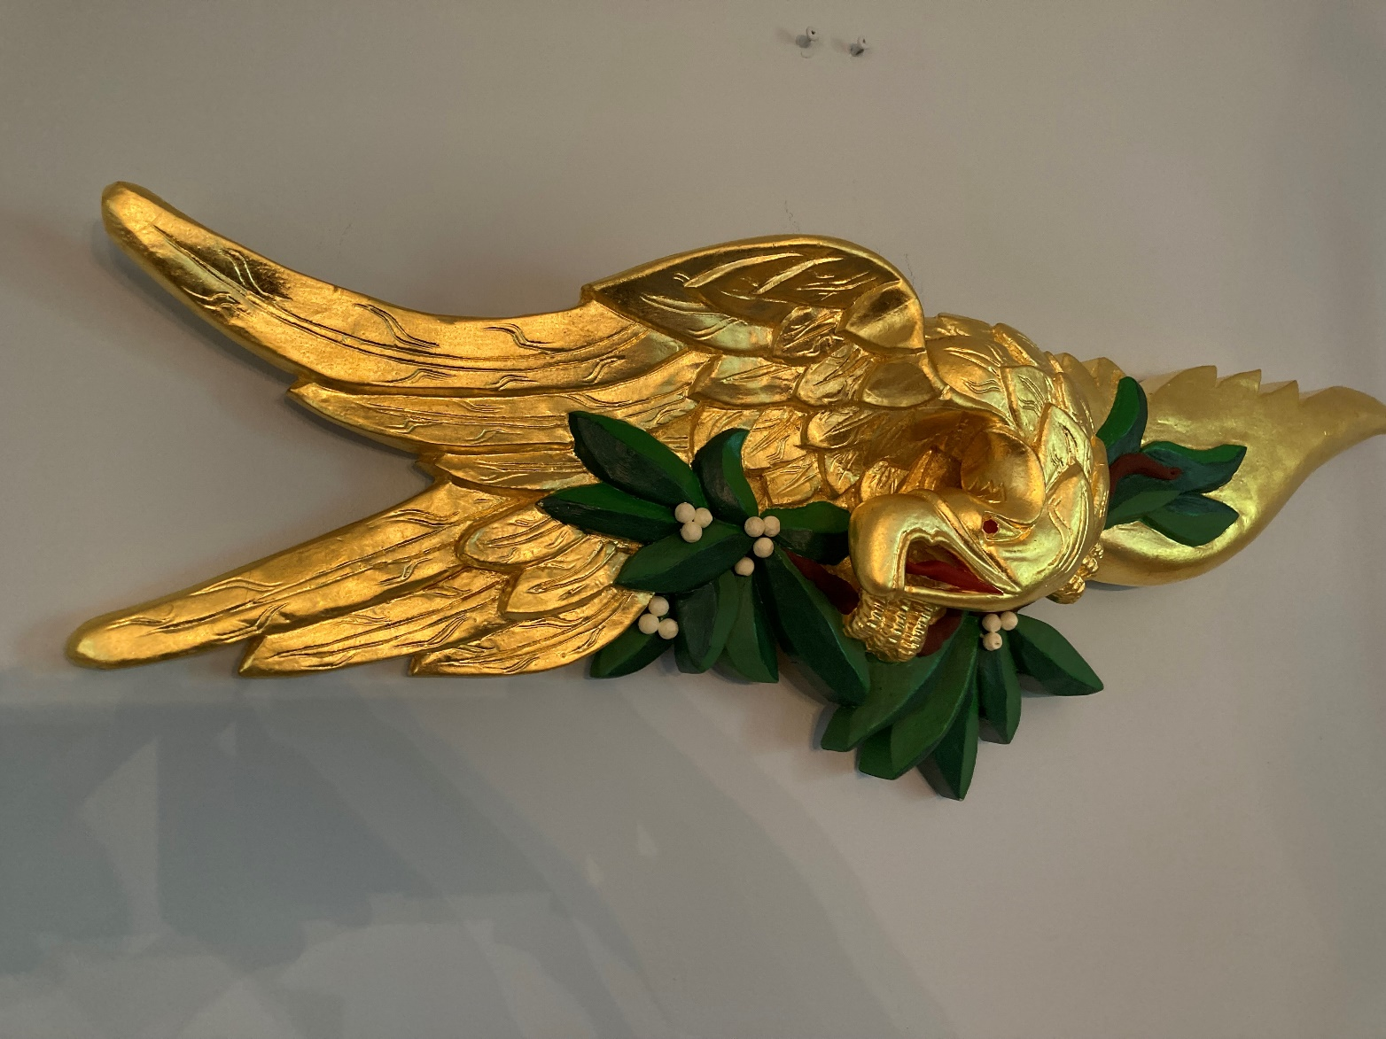

Reverse Wing Bellamy 33” span x 11” tall x 4” deep $4,500

12. 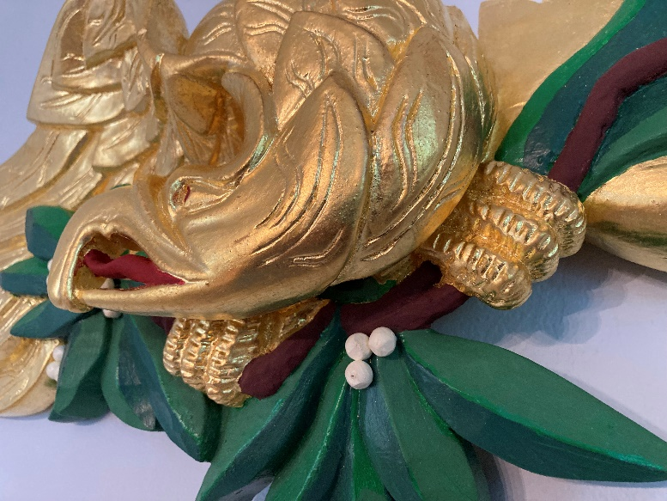 Detail of #12

___________________________________________________________________________________

13. 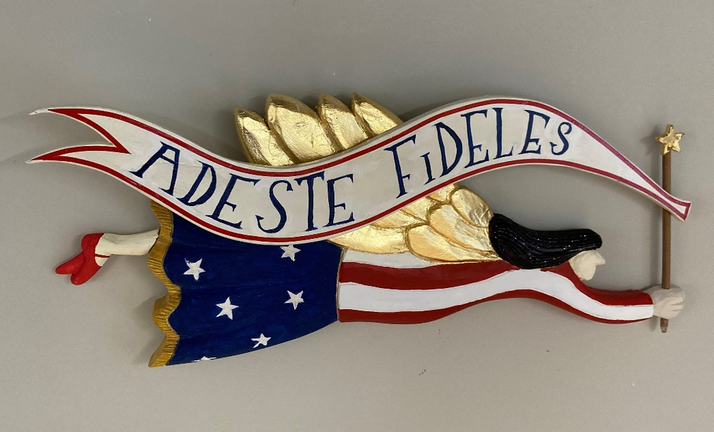
Folk Angel original design $725

14. 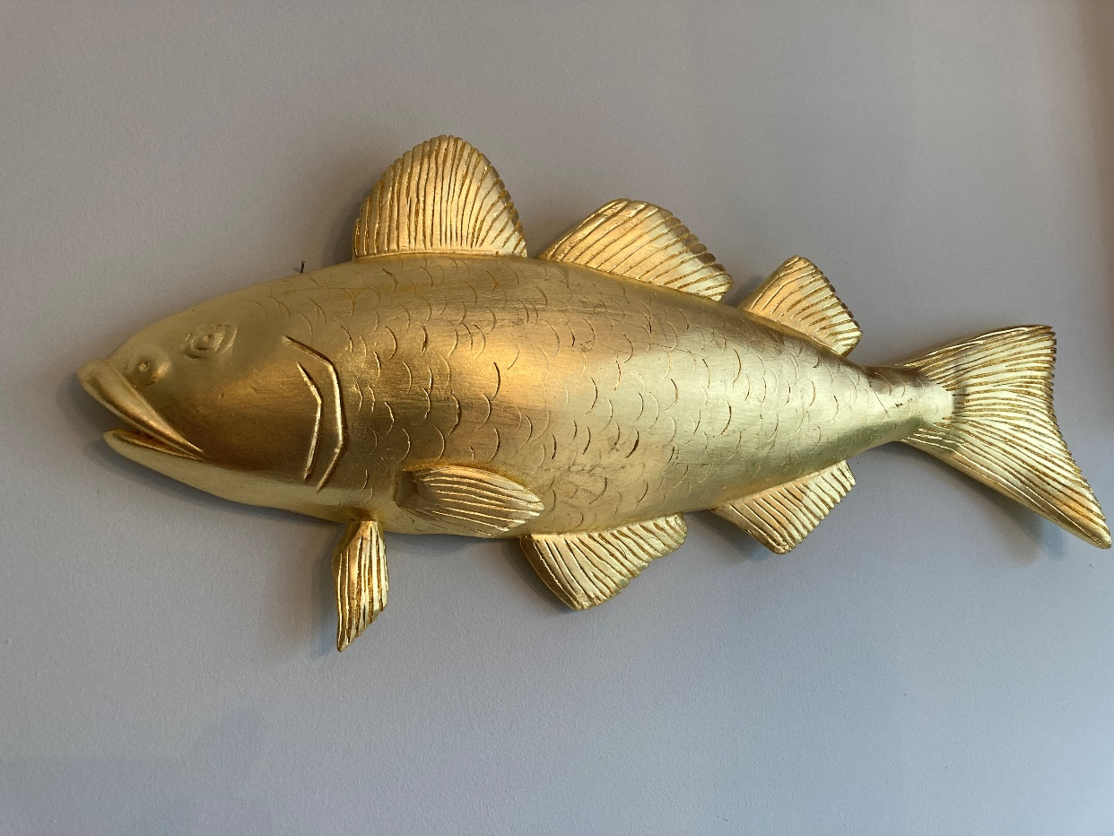

Codfish

26” available for immediate shipment. $1600

Available At Main Street Gallery, Falmouth, MA and at Small Wonder Gallery, Camden, Maine

I have a number of codfish blanks I have prepared, so this can be carved with a wait time of only one month. Also available in natural mahogany or walnut. As with all my carvings, I can carve any size to fit your space.

15. Pineapple

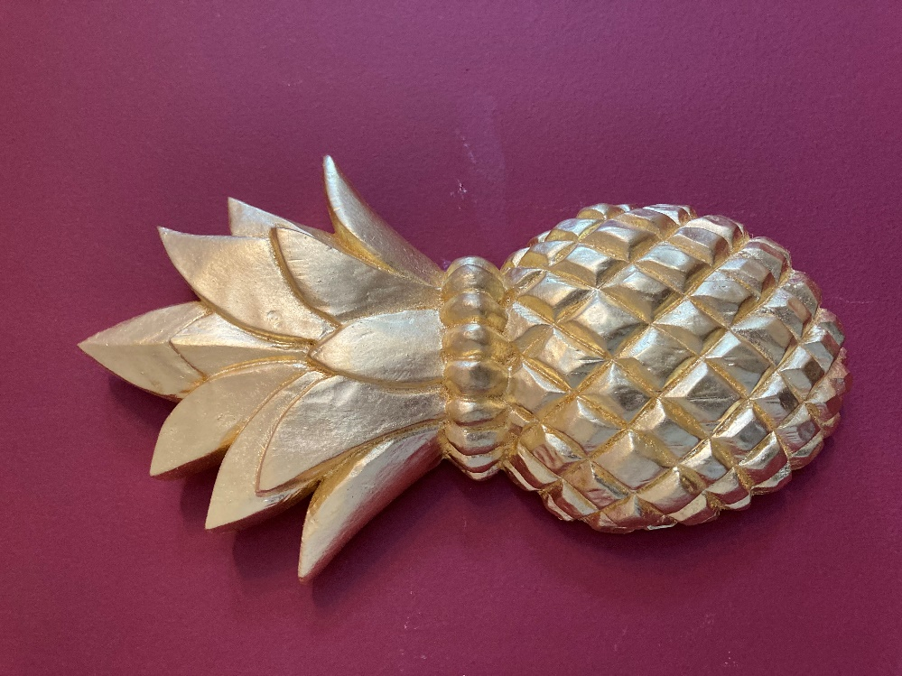

12” tall available at Main Street Gallery, Falmouth, MA & Small Wonder Gallery, Camden, Maine $900

Can carve any size with approx. 1 month lead time. Some folks like the foliage painted Hunter Green
__________________________________________________________________________

16. 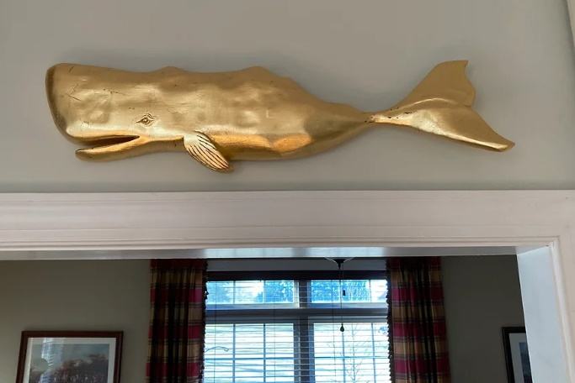
Whale 29 Inches $1500. I can carve any size with 1 month wait time.

17. 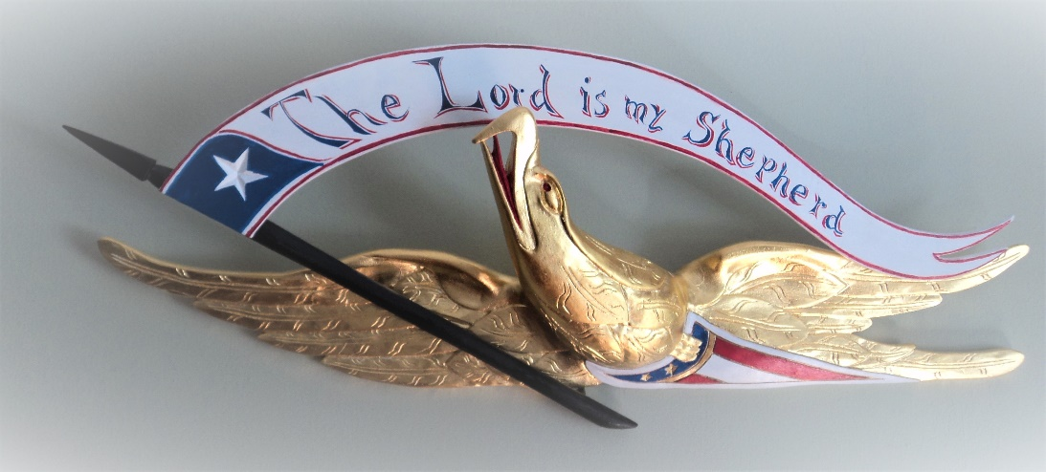

24” span x 9 ½ x 3” SOLD $4,000

‘The Lord is My Shepherd’ Bellamy style Eagle

18. 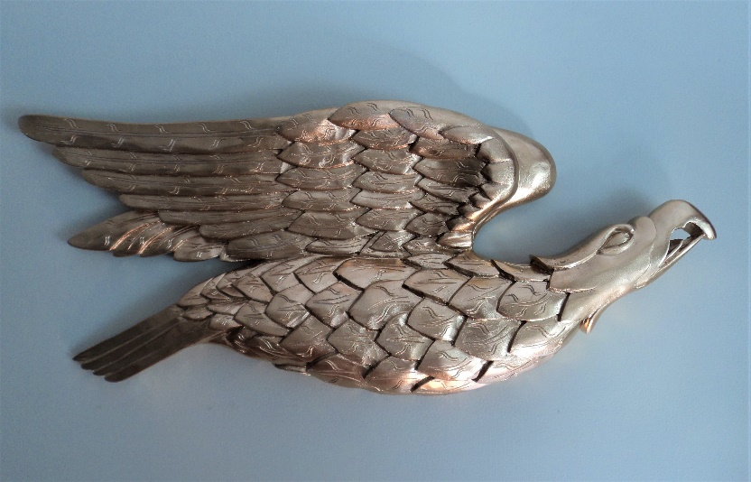
25” span x 11” tall x 2 “ deep $3000

‘Soaring’ Bellamy Eagle Burnished, antiqued gold leaf

___________________________________________________________________________________________

19. Classic Bellamy Eagle
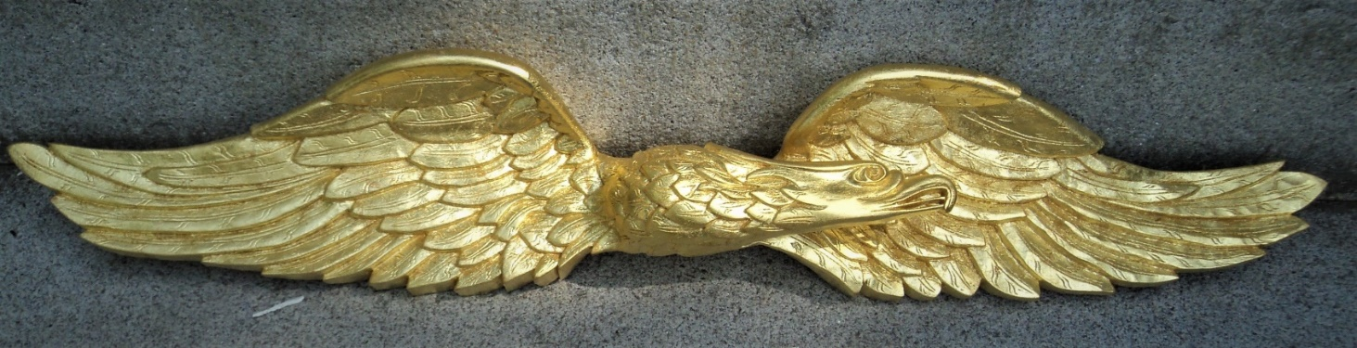
Available at Main Street Gallery, Falmouth, MA. 54” and 34” sizes. Both SOLD $6,000/$5000
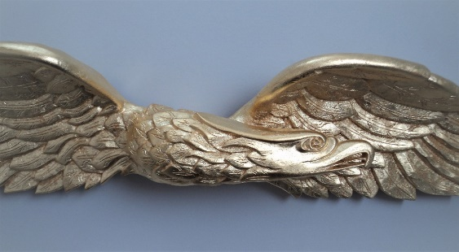
20. 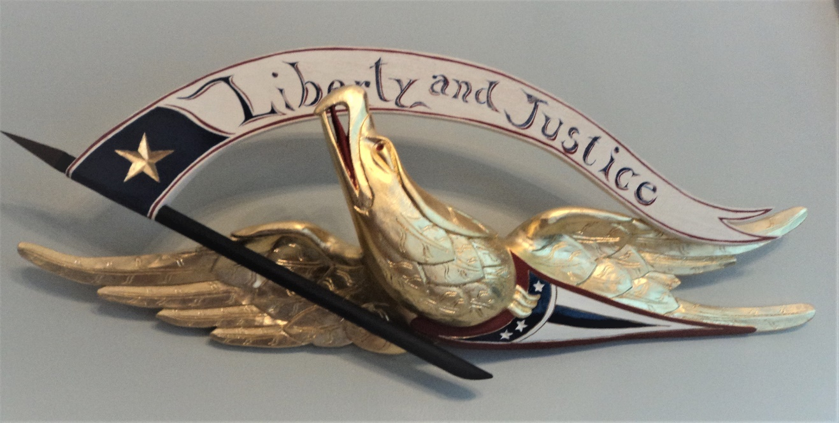
‘Liberty & Justice’ Bellamy style Eagle 29” span x 15 x 4” $3,500

21. 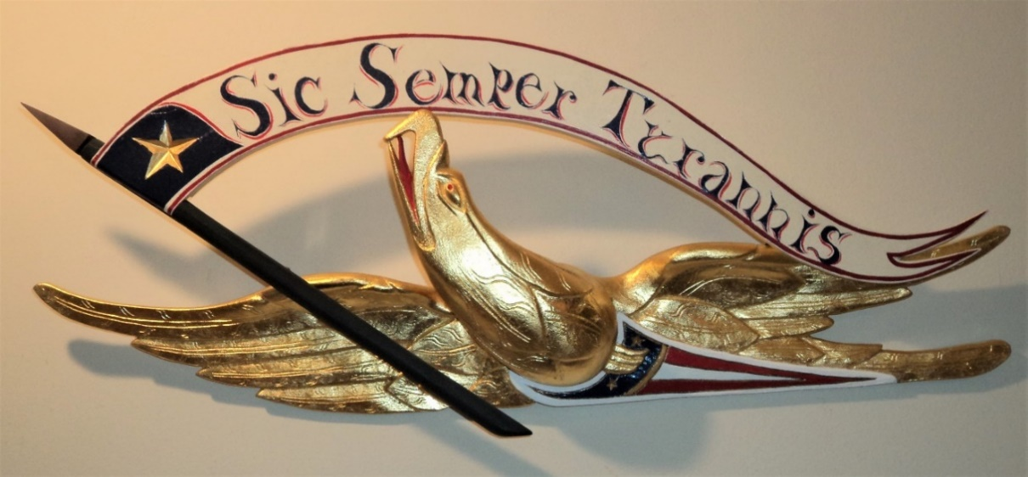
Sic Semper Tyrannis’ (Thus always to Tyrants) Bellamy 24½” span x 9½ x 3½ “
$2,500

22. 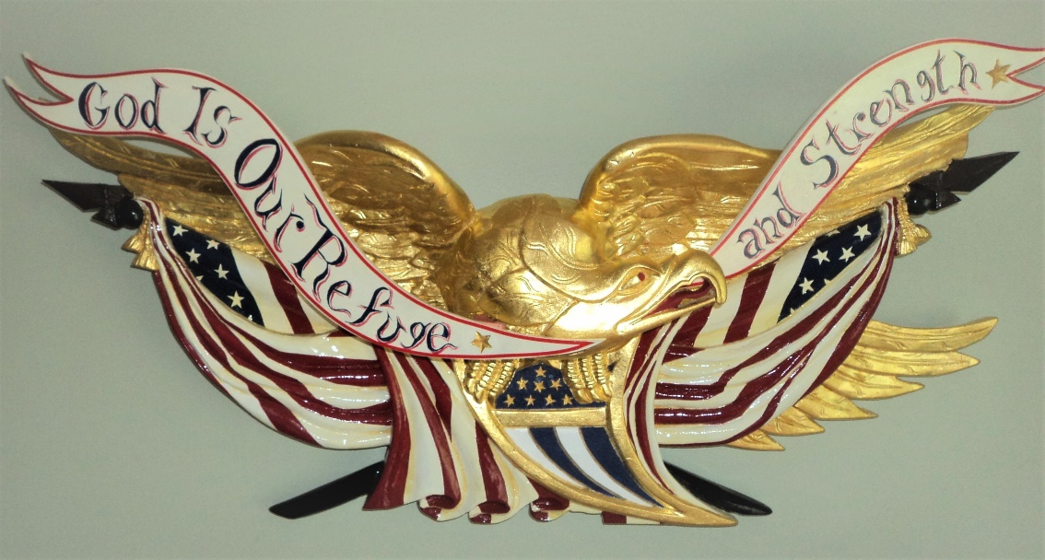
‘God is Our Refuge and Strength’ Bellamy Eagle $12,000
35 ½” span x 14” tall x 5” deep Available with or without banner.

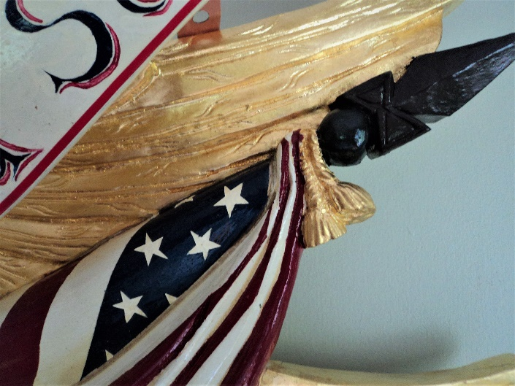 Detail of #22
__________________________________________________________________________________________

23. ‘Faith, Hope, & Charity’ Bellamy Eagle 30 inch x 8 x 4 1/2 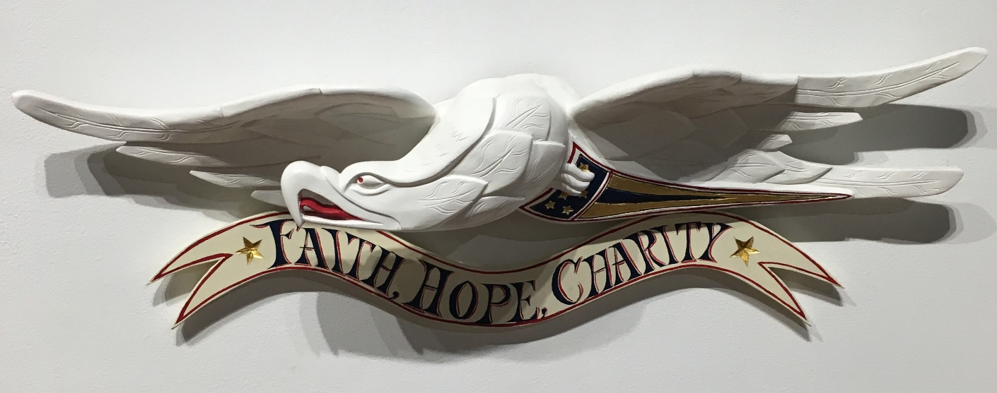
SOLD $5500

24. 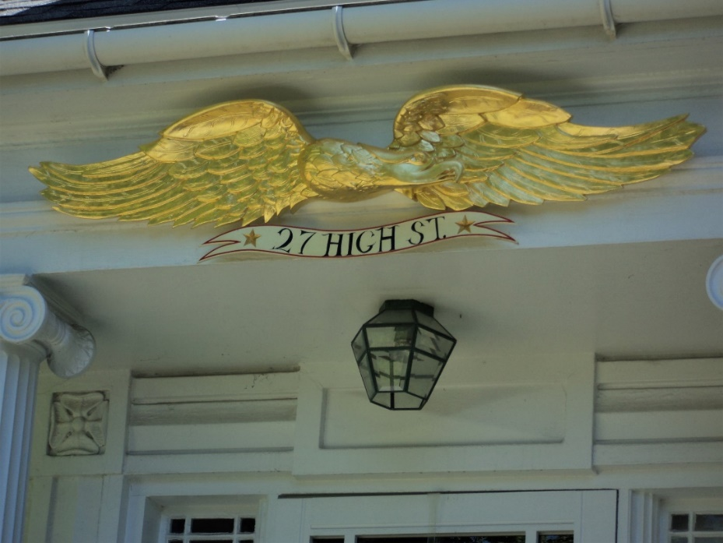
Classic Bellamy style Eagle 62” x 11” tall without banner. Can make this any length and height can vary to fit your space. Add banner of your choice or go without (extra charge). SOLD $8000

25. 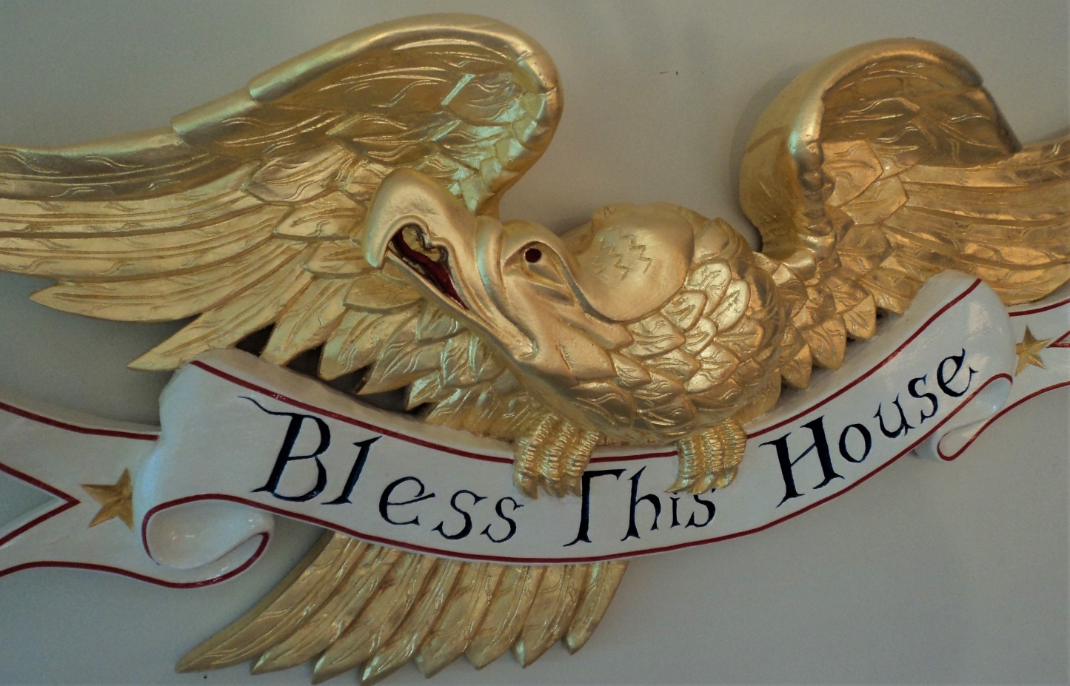
‘Bless This House’ eagle (original design) 36” span x 16” tall x 4” deep
$6,500

26. ‘Freedom’ Bellamy style Eagle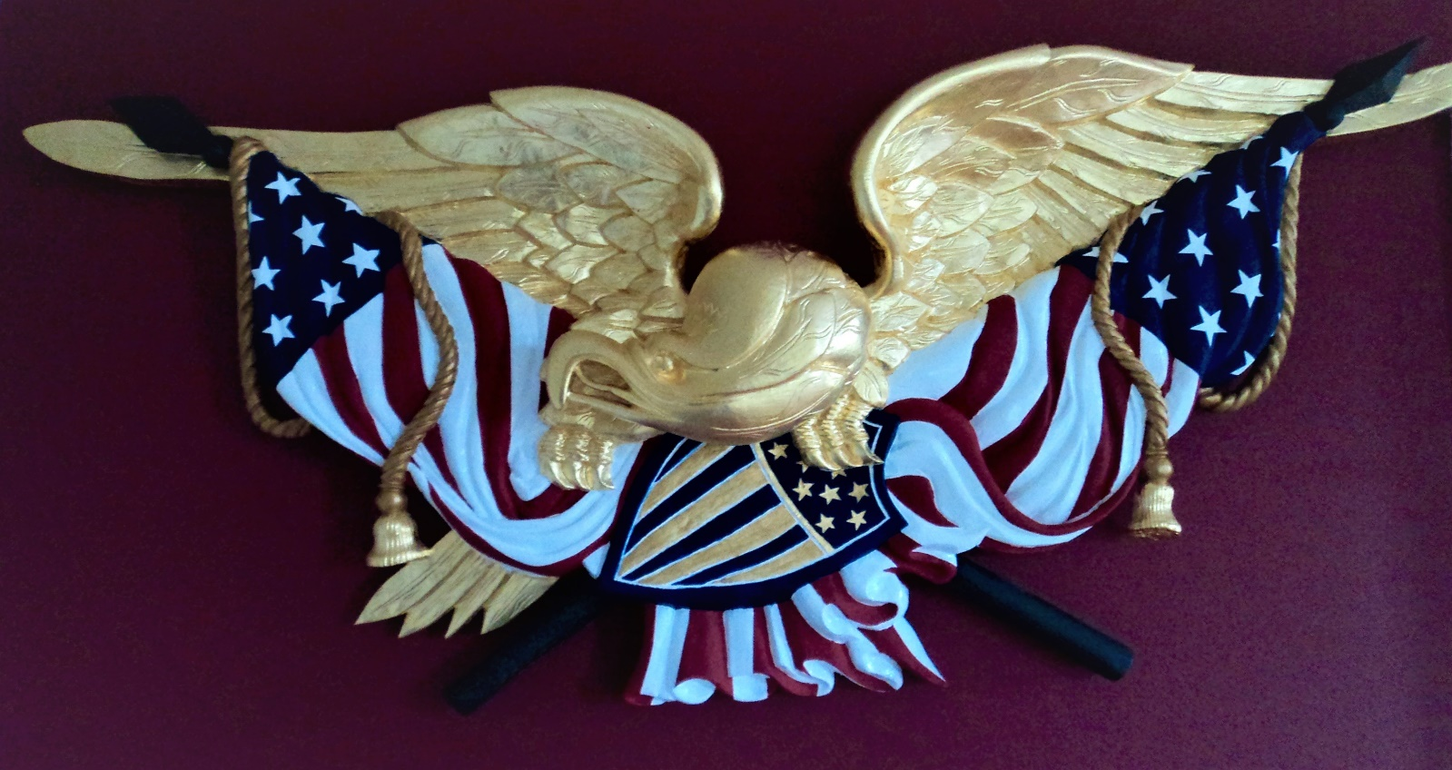
43” wingspan $15,000
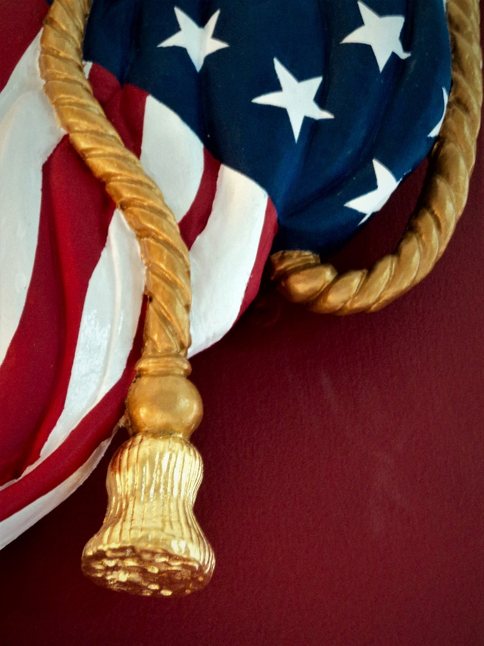 Detail of #26

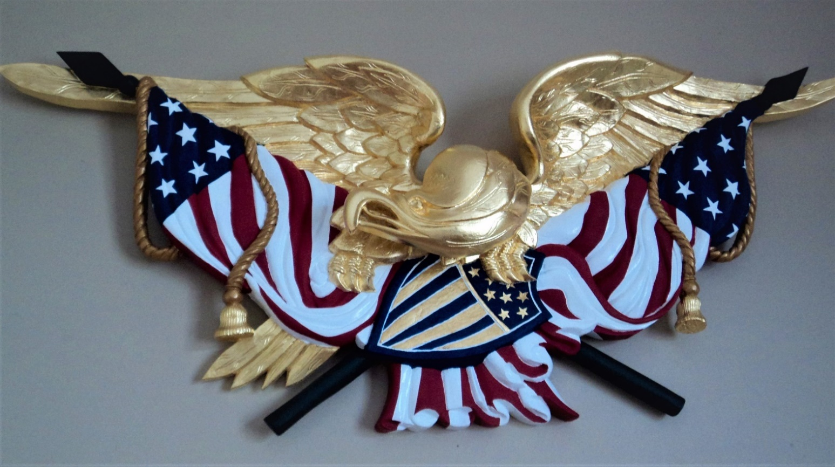

27. 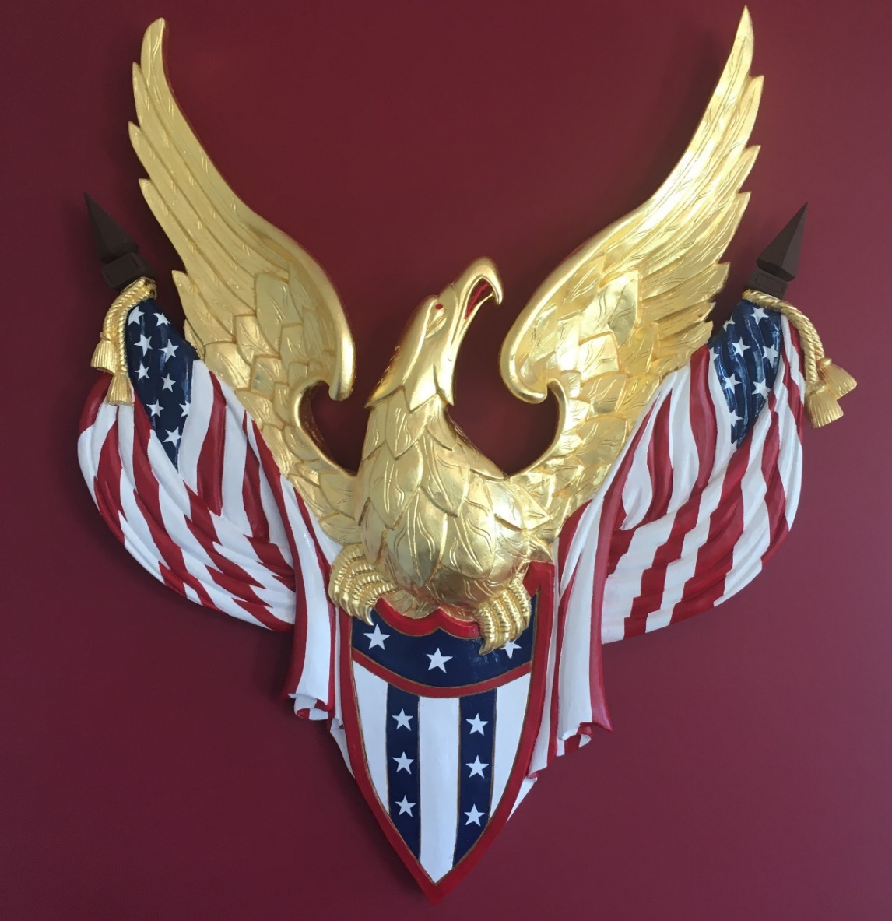

Vertical Bellamy 4 feet x 4 feet x 4” deep $15,000

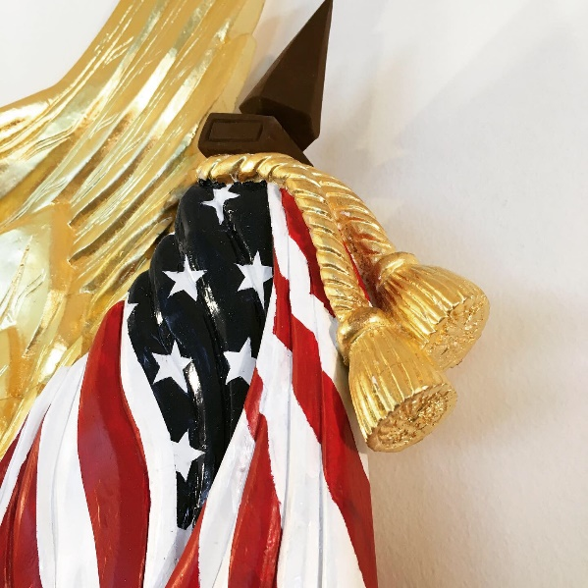 Detail of #27

28. 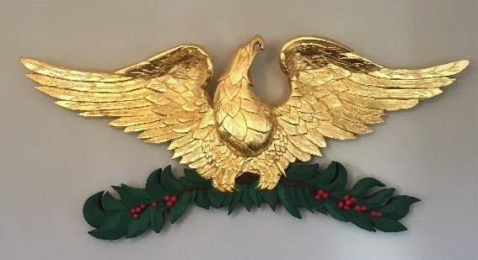

Yuletide Eagle (original design) 50” span x 23” tall x 4” deep $8,000

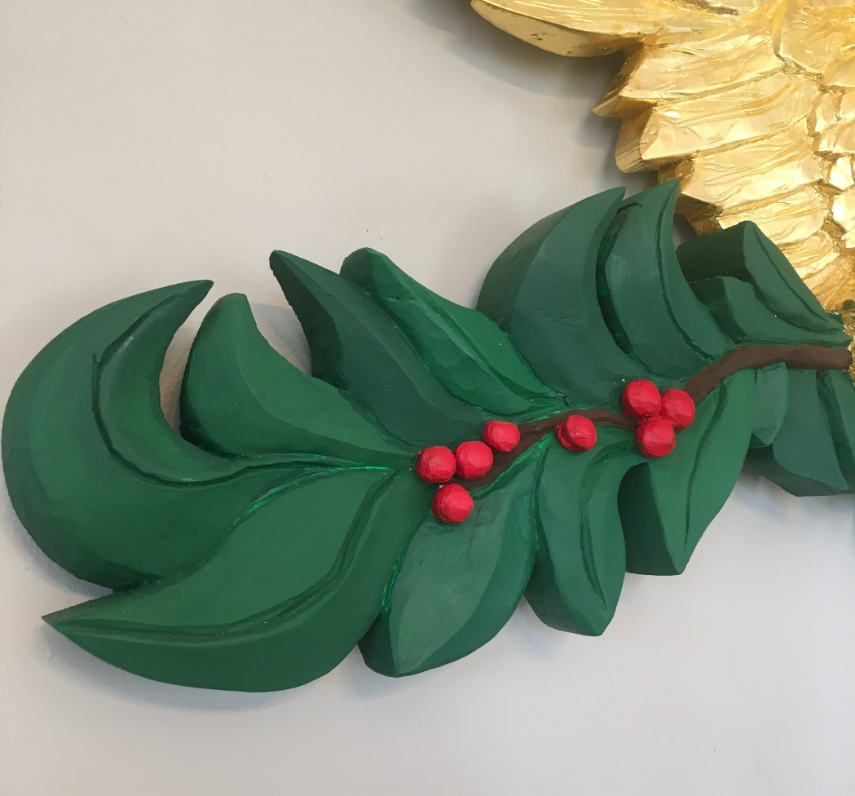 Detail of #28

29. Spread Wing Bellamy style Eagle – SOLD $15,000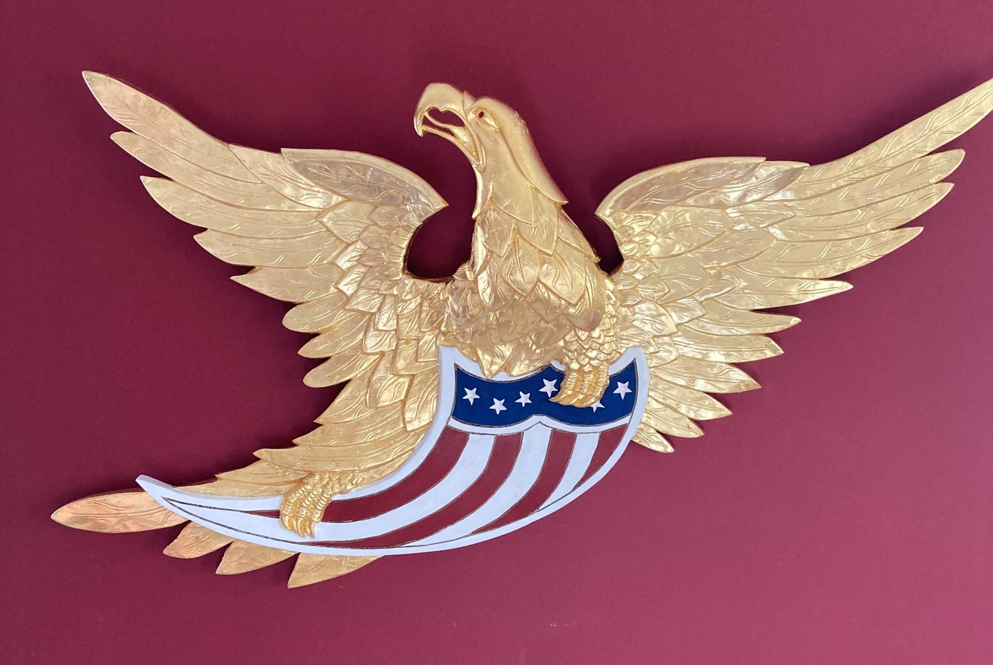
4 feet x 4 feet

30. 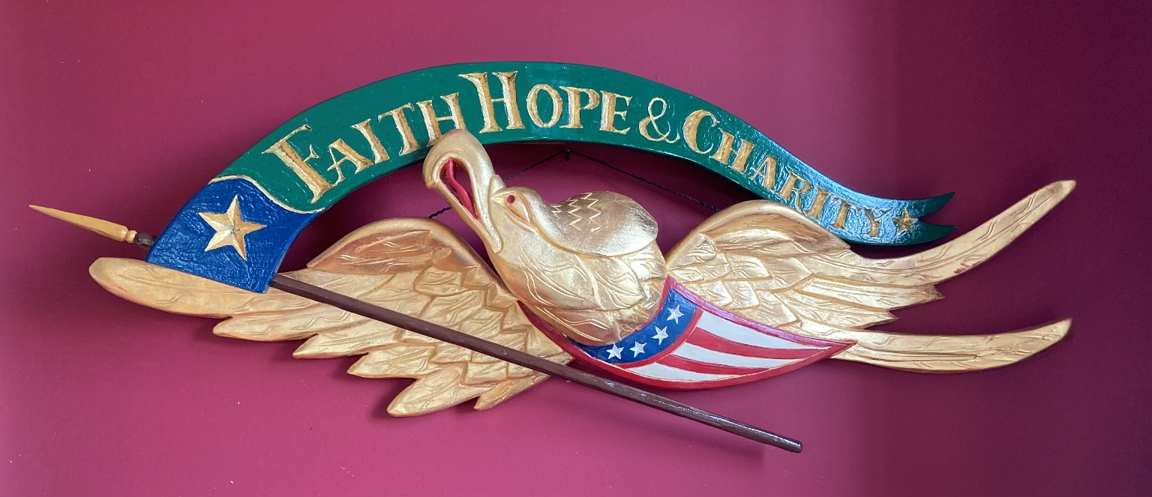

“Faith, Hope, Charity” Bellamy style Eagle 32” wingspan $4,500 SOLD

31. 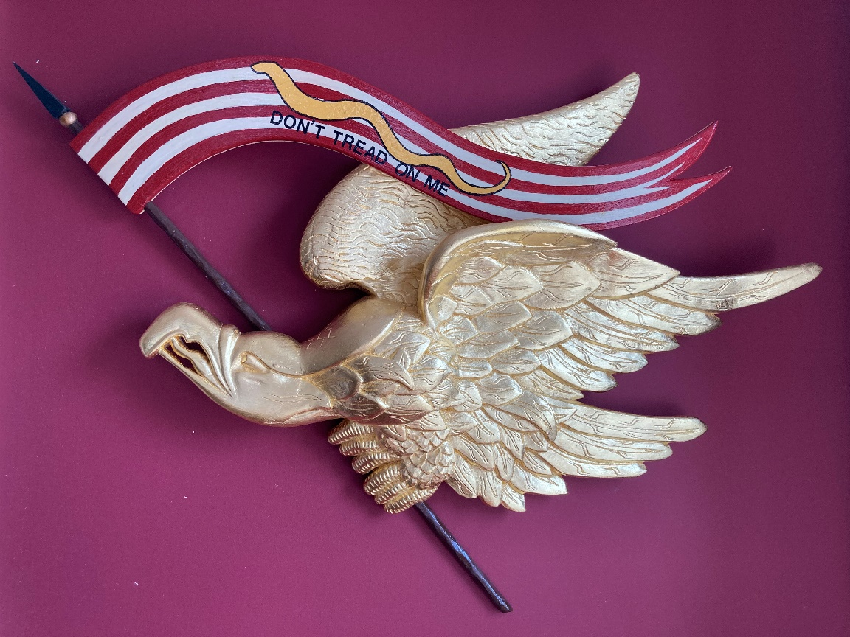
Liberty eagle 33” wide x 23” tall x 4” deep. More Banner styles available or can customize $5,500

32. 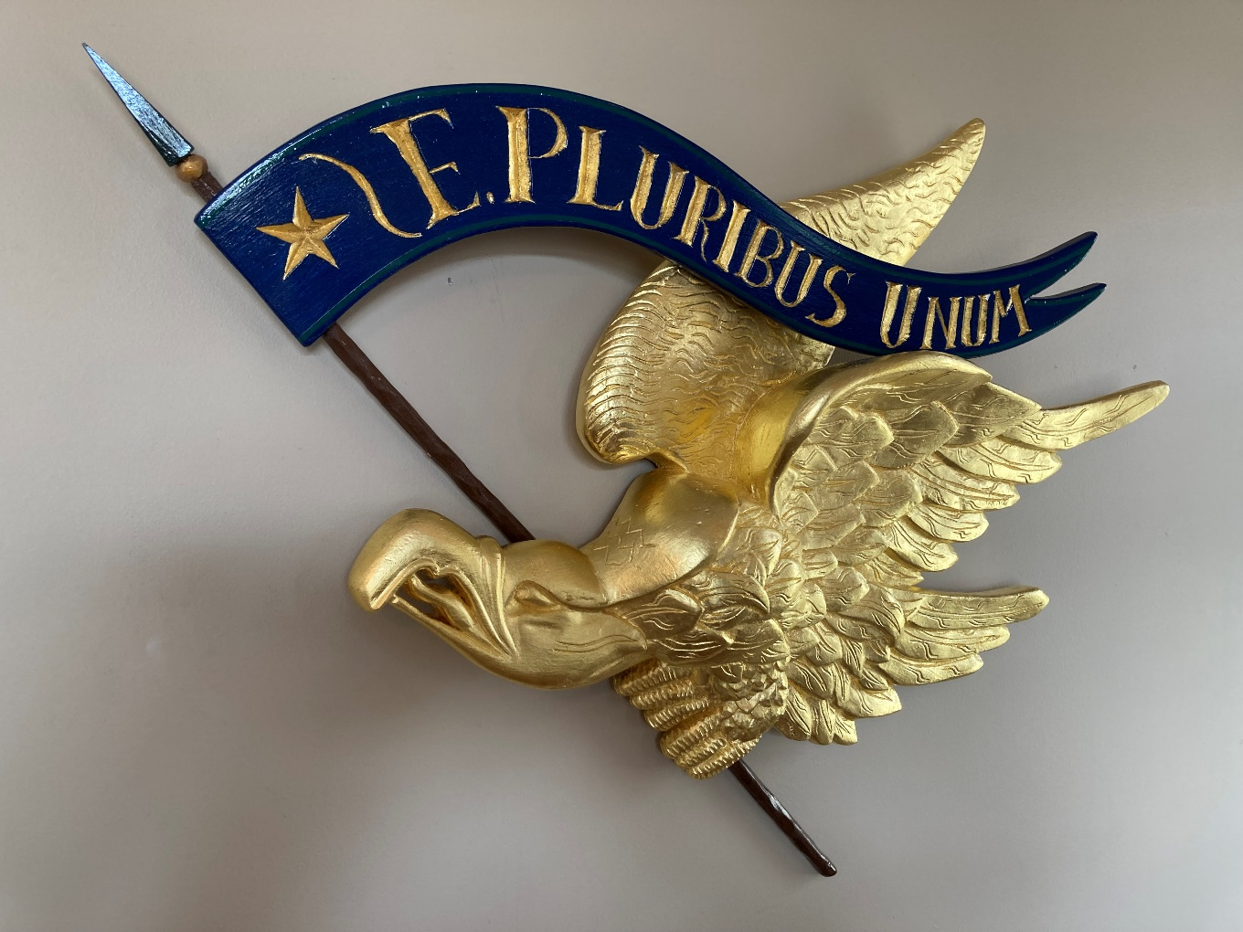
“E. Pluribus Unum” Liberty Eagle

33. 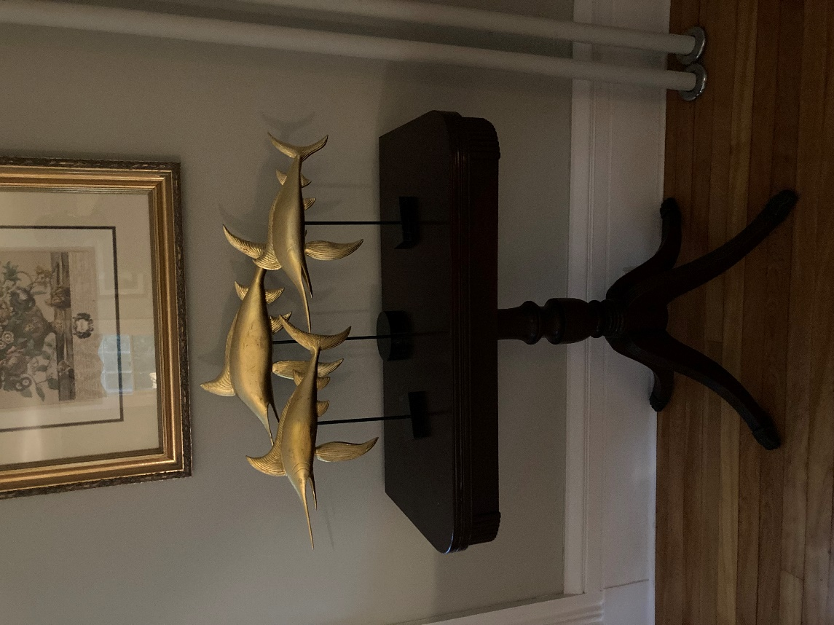

Swordfish 8-12 inches All carvings are gilded with 24 karat gold
$750 each; 3 for $2000

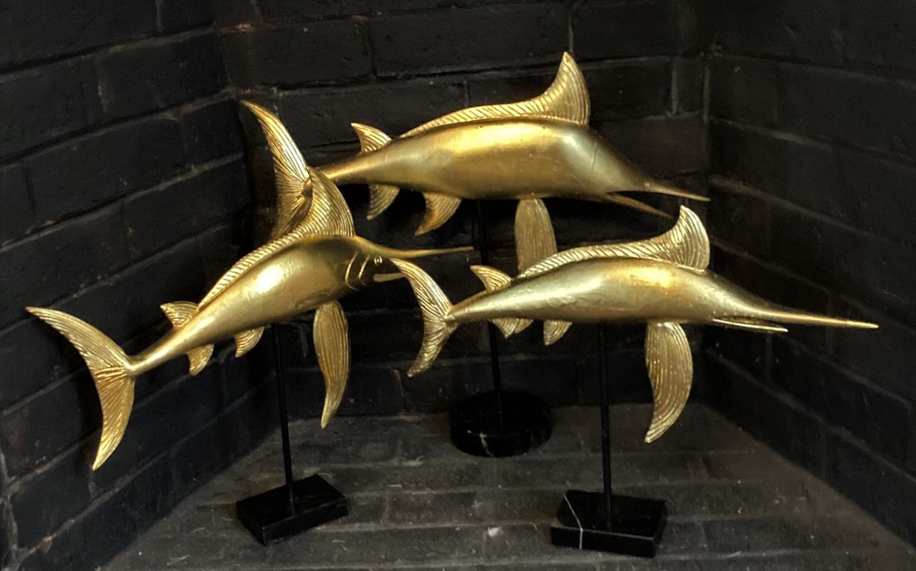

Swordfish also available for immediate sale in in Extra Large size: 47” wide x 23” tall $3,200 (see below)
24 karat gold leaf……………

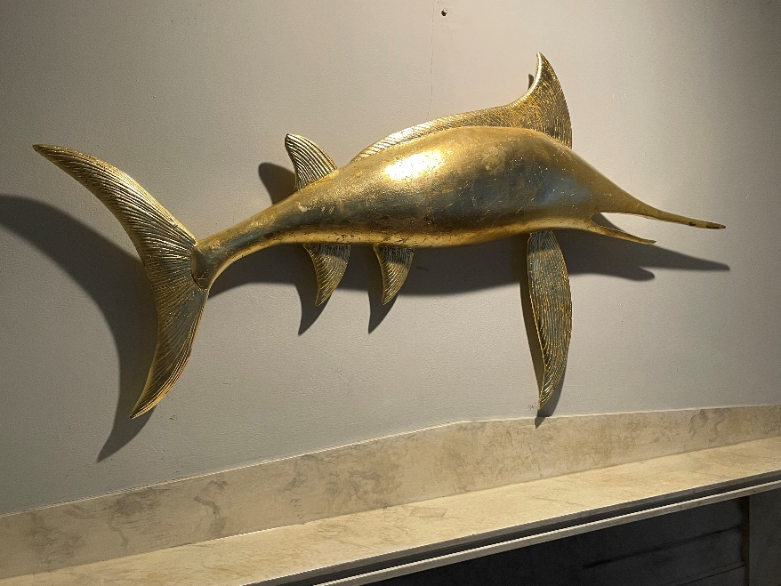

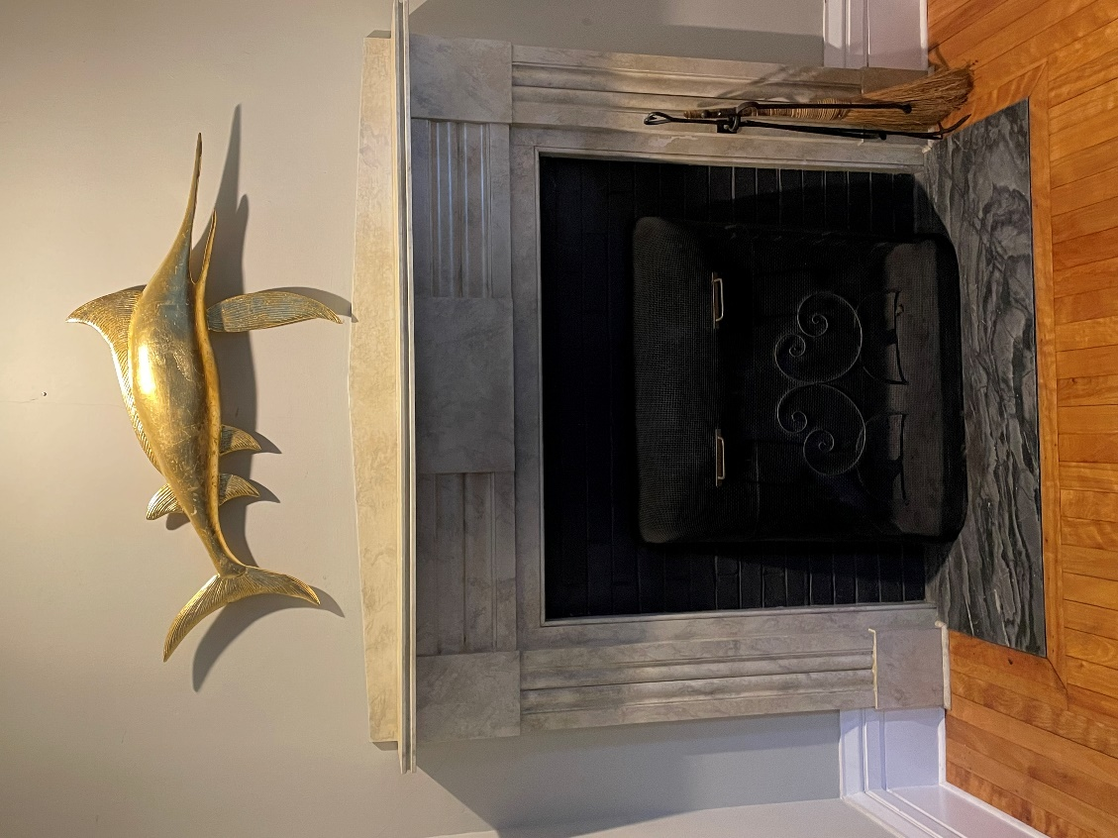

___________________________________________________________
Custom House Signs and Quarterboards:

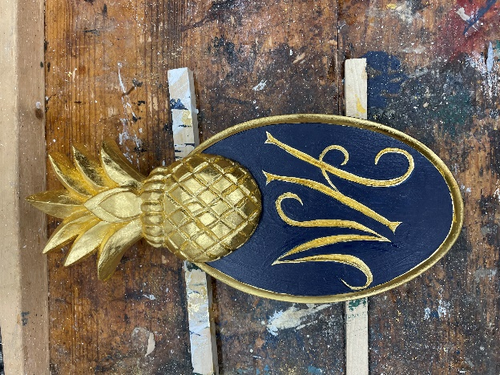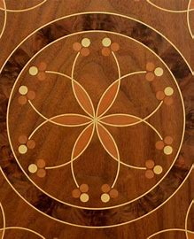

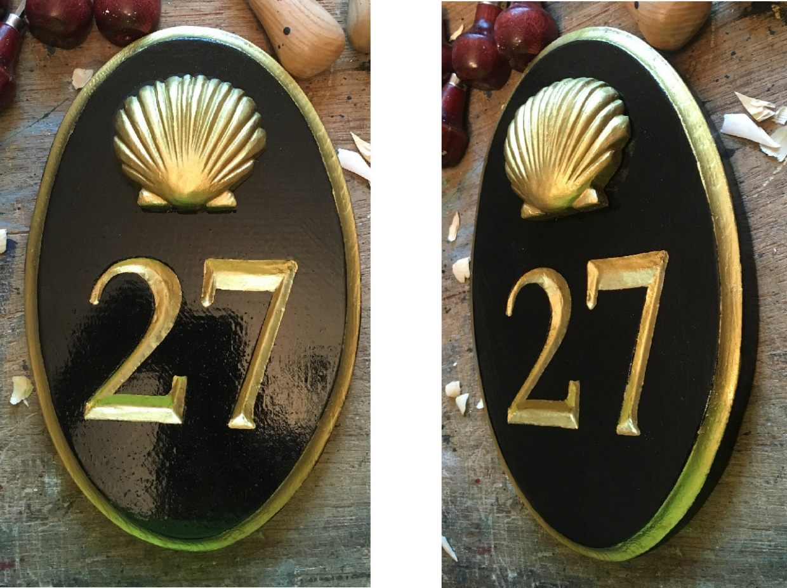

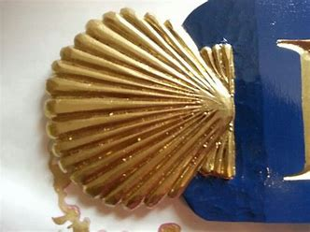

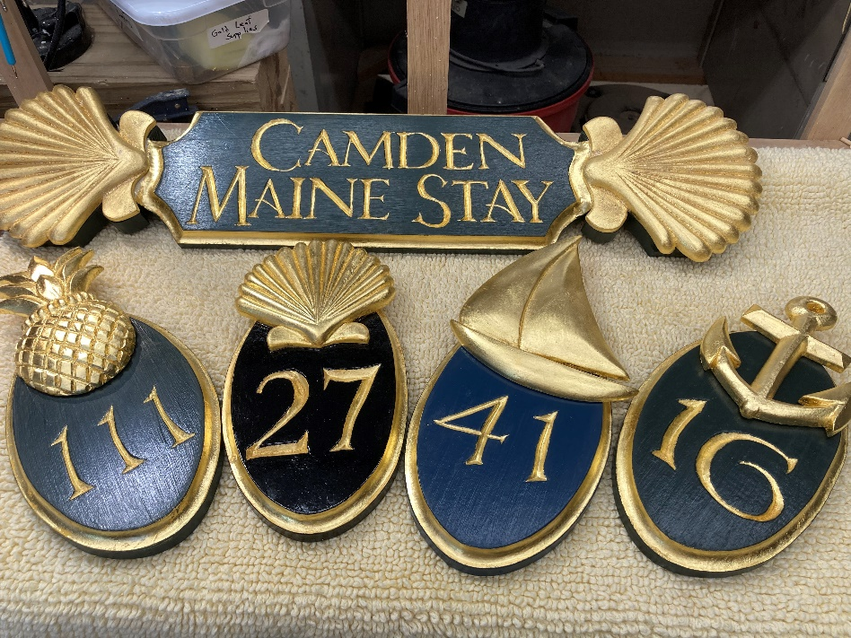
Instagram: William Francis Brown (@williamfrancisbrown)

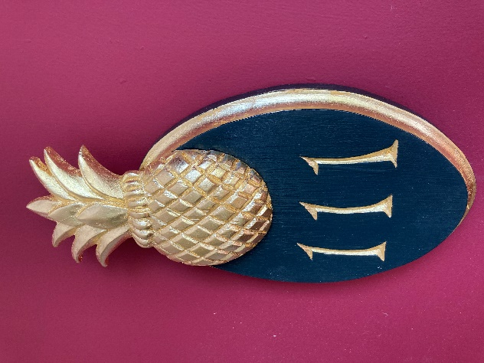

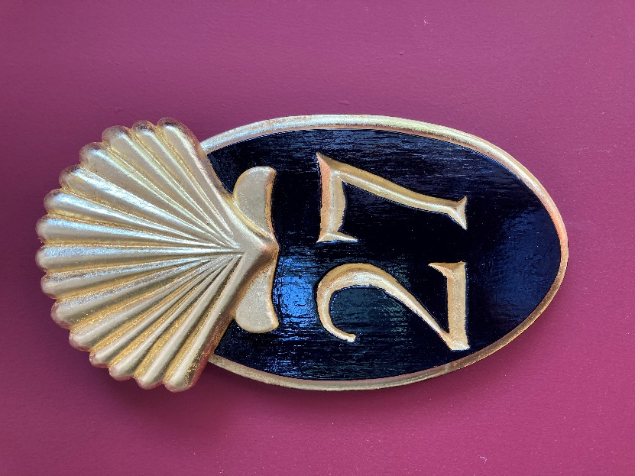

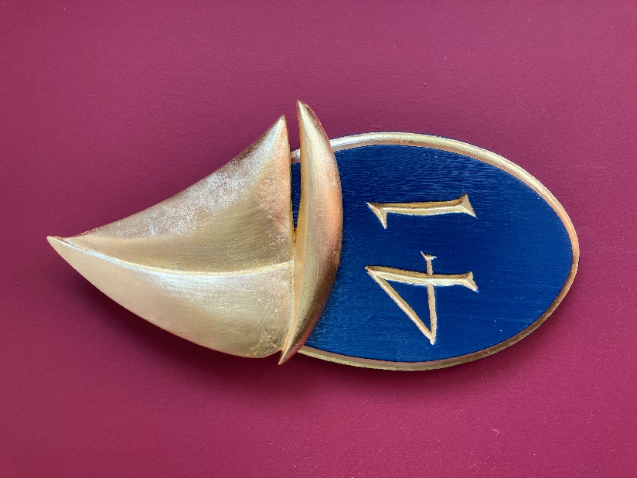

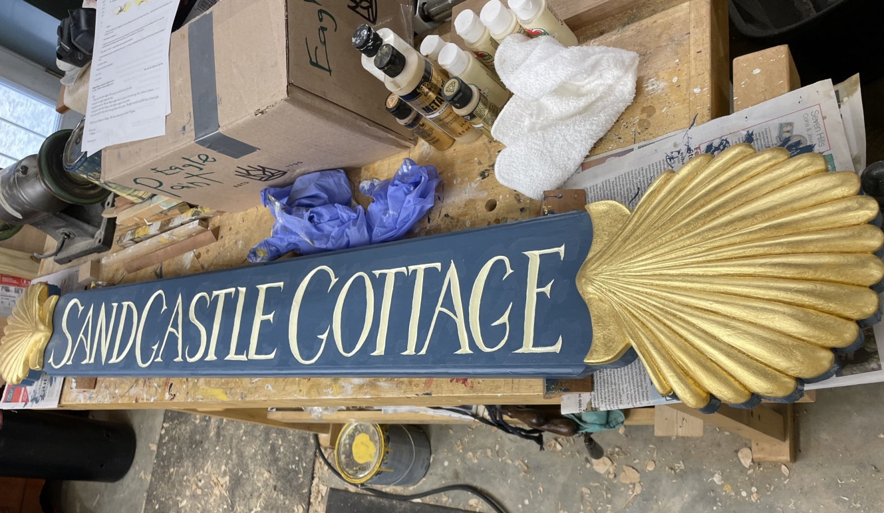
Quarterboards/Signs – Any size and style
This one is 6 feet long, 24 karat gold leaf carved shells;
$4,000 and up

Peace Eagle
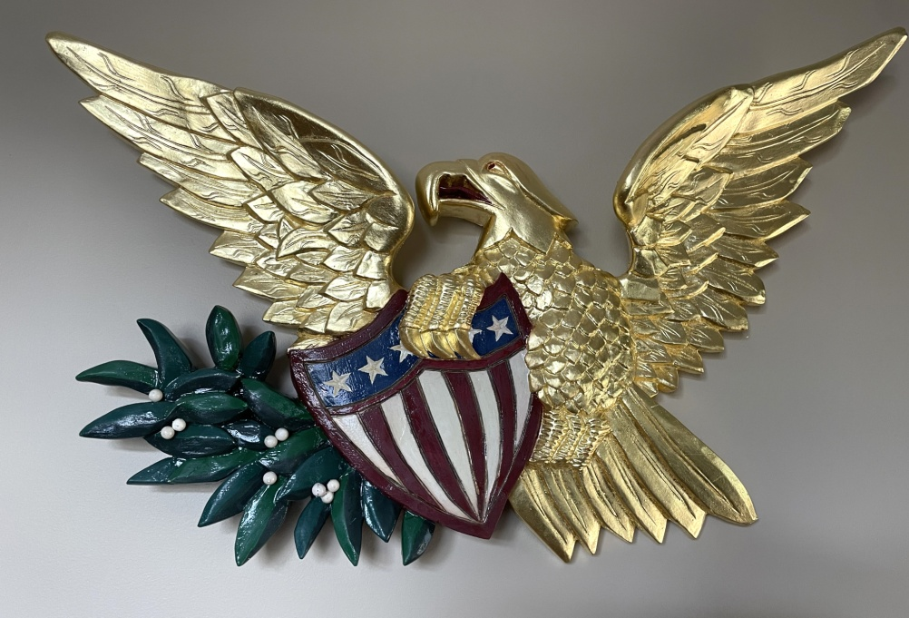
Right facing toward olive branch represents ‘peace’

30” span x 24” high Original design $5,500

Contact Info:
Wm. Francis Brown
Email: dei.gratia123@gmail.com
Instagram: @williamfrancisbrown

